Software Requirements Specification

Children Monitoring System Android

Software Requirements Specification

1.4

11/27/2017

Aditya Srimat Tirumala Pallerlamudi

Venkata Naga Kamal Nadh Meduri

Anil Seshu Kumar Akula

Yeshwanth Rangineni

Saidevi Uppalapati

Sandeep Mulakala

Jyothsna Pala

Submitted in partial fulfilment

Of the requirements of

CSIS 44-691 Graduate Directed Project 1

# Revision History

|  |  |  |  |
| --- | --- | --- | --- |
| **Date** | **Description** | **Author** | **Comments** |
| 09/15/2017 | 1.0 | Team | Discussed the scope and added the initial requirements. |
| 09/29/2017 | 1.1 | Aditya S T P, Kamal Meduri | Included the Design related documentation for the project. |
| 10/13/2017 | 1.2 | Aditya S T P | Modified the Data Flow Diagram and Sequence Diagram. |
| 11/17/2017 | 1.3 | Aditya S T P | Added the User Manual chapter. |
| 11/27/2017 | 1.4 | Aditya S T P | Added the System Manual chapter. |

# Document Approval

The following Software Requirements Specification has been accepted and approved by the following:

|  |  |  |  |
| --- | --- | --- | --- |
| **Signature** | **Printed Name** | **Title** | **Date** |
| Jyothsna | Jyothsna Pala | Business Analyst | 09/15/2017 |
| Anil | Anil Seshu Kumar Akula | UI Designer | 09/29/2017 |
| Anil | Anil Seshu Kumar Akula | UI Designer | 10/13/2017 |
| Jyothsna | Jyothsna Pala | Business Analyst | 11/17/2017 |

**Table of Contents**

**Table of Contents Page Number**

1. Introduction
   1. Purpose 1
   2. Scope 1
   3. Definitions, Acronyms, and Abbreviations 1
   4. References 1
   5. Overview 1
2. General Description
   1. Product Perspective 1
   2. Product Functions 1
   3. User Characteristics 1
   4. General Constraints 2
   5. Assumptions and Dependencies 2
3. Specific Requirements
   1. External Interface Requirements 2
      1. User Interfaces 2
      2. Hardware Interfaces 2
      3. Software Interfaces 2
      4. Communications Interface 2
   2. Functional Requirements 3
   3. Use cases 3
   4. Classes / Objects 3
   5. Non-Functional Requirements 3
      1. Performance 4
      2. Reliability 4
      3. Availability 4
      4. Security 4
      5. Portability 4
   6. Inverse Requirements 4
   7. Design Constraints 4
   8. Logical Database Requirements 4
   9. Other Requirements 5
   10. Use Case Diagrams 5
4. Design
   1. ER Diagram 6
   2. GUI 7
5. Analysis Models
   1. Data Flow Diagram 10
   2. Sequence Diagram 10
6. User Manual
   1. Install the application 11
   2. Register 11
   3. Login 11
   4. Add a Child 12
   5. Track location of the child 13
   6. Track activities of the child 14
   7. Track history of the child 15
   8. Change settings 16
7. System Manual
   1. Application Requirements 16
   2. Application Usage
      1. Install the application 17
      2. Register 17
      3. Login 17
      4. Add a Child 18
      5. Track location of the child 19
      6. Track activities of the child 20
      7. Track history of the child 21
      8. Change settings 22
   3. Add User/Delete User
      1. Add a User 23
      2. Delete a User 23

## Introduction

* 1. **Purpose**: The main purpose of the project is to provide a Children monitoring application for the parents in order to monitor the activities of their children. It records the data of the child location and maintains a history for the same. It provides the location information of the children to the parent.
  2. **Scope**: This system provides the parent with the information of child location but not the activities performed by the children and the video recording of the children.
  3. **Definitions, Acronyms, and Abbreviations**:
* CMS: Children Monitoring System
* GPS: Global Positioning System
* Use Case: A disciplined method of describing the typical behavior of a component of the system.
  1. **References**: Below are the references used for understanding of the project concept
* <https://www.researchgate.net/publication/302583667_Developing_a_Children_Monitoring_System_for_Mobile_Devices>
  1. **Overview**: Using the collaboration of GPS and smart device in the project development leads to a technology touch to people who wants to track their children.

## General Description

* 1. **Product Perspective**: The Product perspective is of the parent perspective and from which parent can monitor and as well as manage the details/information of the children added in the application.
  2. **Product Functions**: The main function is to track the location of the child based on GPS and it records into the historical data of the parent mobile device.
  3. **User Characteristics**:

Client: Person/organization for whom the software has developed. The client wishes to see the design as required out by the system and be able to see what exactly they are buying.

Business Analyst: Person considered as the general advisor and analyzing expert who is responsible for finalizing the requirements and consider all the main factors related to the project.

Team Lead: A team leader is the person who provides the instructions and information to a group of individuals i.e. team, who are responsible for achieving a certain goal.

UI Designers: People who design the application with mockups and User interface. They use the requirements of the project and design the user interface for the system.

Software Developers: People who develop the code according to the design/layout and make the application work with respect to the client requirement. They also maintain the existing code of the application if any issue comes in the application.

Quality Analyst: Users who are responsible for testing the application and ensure that the developed application is intact with the requirements and issue-free. In addition, the code is feasible and working in all scenarios and conditions.

Database Engineer: The person who deals with the entire database of the system and handles any glitches in the database when any update/changes in the development occur.

* 1. **General Constraints**: Application provides the login form in which parent needs to enter credentials with unique username/password for each child. This factor is the main constraint.
  2. **Assumptions and Dependencies**: All the major tasks of the project categorized based on their respective dependencies and this step followed by initial project requirements identification and initial system setup. The hardware and software has upgraded to the required level and finally a network has to be setup that includes software-network interactions as well as network integrity.

## Specific Requirements

* 1. **External Interface Requirements**
     1. User Interfaces: User interface of the application rely on the layout and the performance. UI Designer is the responsible person for creating creative and ease-of-use user interface.
     2. Hardware Interfaces: Network of devices connected to each other leads the product work efficiently.
     3. Software Interfaces: In order to work the code expectedly, software should built accurately and without bugs.
     4. Communications Interface: Communication plays a key role in the team in order to express their views, ideas and to give their best for the project.
  2. **Functional Requirements**: Functional requirements are the functionalities dealing with the features in Login page, Homepage, Records management page and Settings page.

**Login page**

1. Create Header/Label displaying the name of the app for all the pages
2. Create Username and password fields in Login page
3. Create 'Sign in' button in Login page
4. Create Forgot password option in Login page
5. Create 'New user/create account' option in the Login page

**Home page**

1. Create 'Add your children' button in Homepage
2. Create/Display the child details as a button in Homepage
3. Ability to display the added child in the Homepage

**Records Management**

1. Display the name and picture of the child
2. Create 'Location' button and trace the location with the help of this button
3. Create 'See history' button and display the data till date
4. Create 'Today Activities' button and display activities to do by parent for the child on that respective day
5. Create 'Delete child' button and confirm before deletion

**Settings**

1. Display name and profile picture of the user (parent)
2. Display email, phone number of the user
3. Create Delete Account button and confirm with the user before deletion
4. Create 'Sign-out' button to log out of the application
   1. **Use Cases**: Information of children provided to the parents. Location tracing, duration of activities in turn can work on safety measures of the children.
   2. **Classes/ Objects**: Parents and children are key entities in the project.
   3. **Non- Functional Requirements**:
      1. Performance: Children aspects are captured through the monitoring device. In any situation their activities are monitored and information is recorded which can be viewed by parents.
      2. Reliability: The technical support team verifies the monitoring system continuously such that if any problem occurs in the project, it is cleared immediately providing an alternative for monitoring.
      3. Availability: All the records of child monitoring system are available to parents in their respective account. They can easily access their accounts in any time.
      4. Security: Login page is developed such that it is required to enter unique credentials for security purpose and can only be logged-in by parents. Database information is always securely protected by providing access to only authorized personals.
   4. **Inverse requirements**: Currently, there are no inverse requirements for this project.
   5. **Design Constraints**: Design constraints for Mobile version (Android) are layout, dimensions of the device, content of page, menu bars, color formatting of contents, navigating through the pages.
   6. **Logical Database and Hardware Requirements**: Below are the hardware and software requirements for the project.

|  |  |  |
| --- | --- | --- |
| **Requirement SNo.** | **Name** | **Description** |
| 1 | Windows PC with 500 GB of HDD | Desktop or Laptop/ Hardware |
| 2 | Android Studio | Software |
| 3 | Latest Java Runtime Environment and Java SE JDK, Android SDK tools | Development software |
| 4 | Android Device | Mobile device |
| 5 | Laptops | Business Laptop’s for developers |
| 6 | SQL server | Database management system software |
| 7 | Printers | Hardware for printing purposes |
| 8 | Wiring, LAN and integration cables | Connection cables |

* 1. **Other Requirements**: Information of police department are required in order to contact them in case of any emergency occurred for the child.
  2. **Use Case Diagrams**

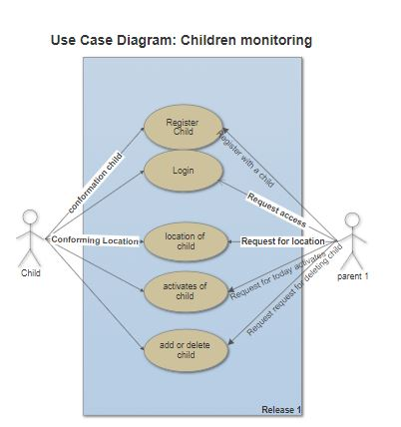

## Design

* 1. ER diagram

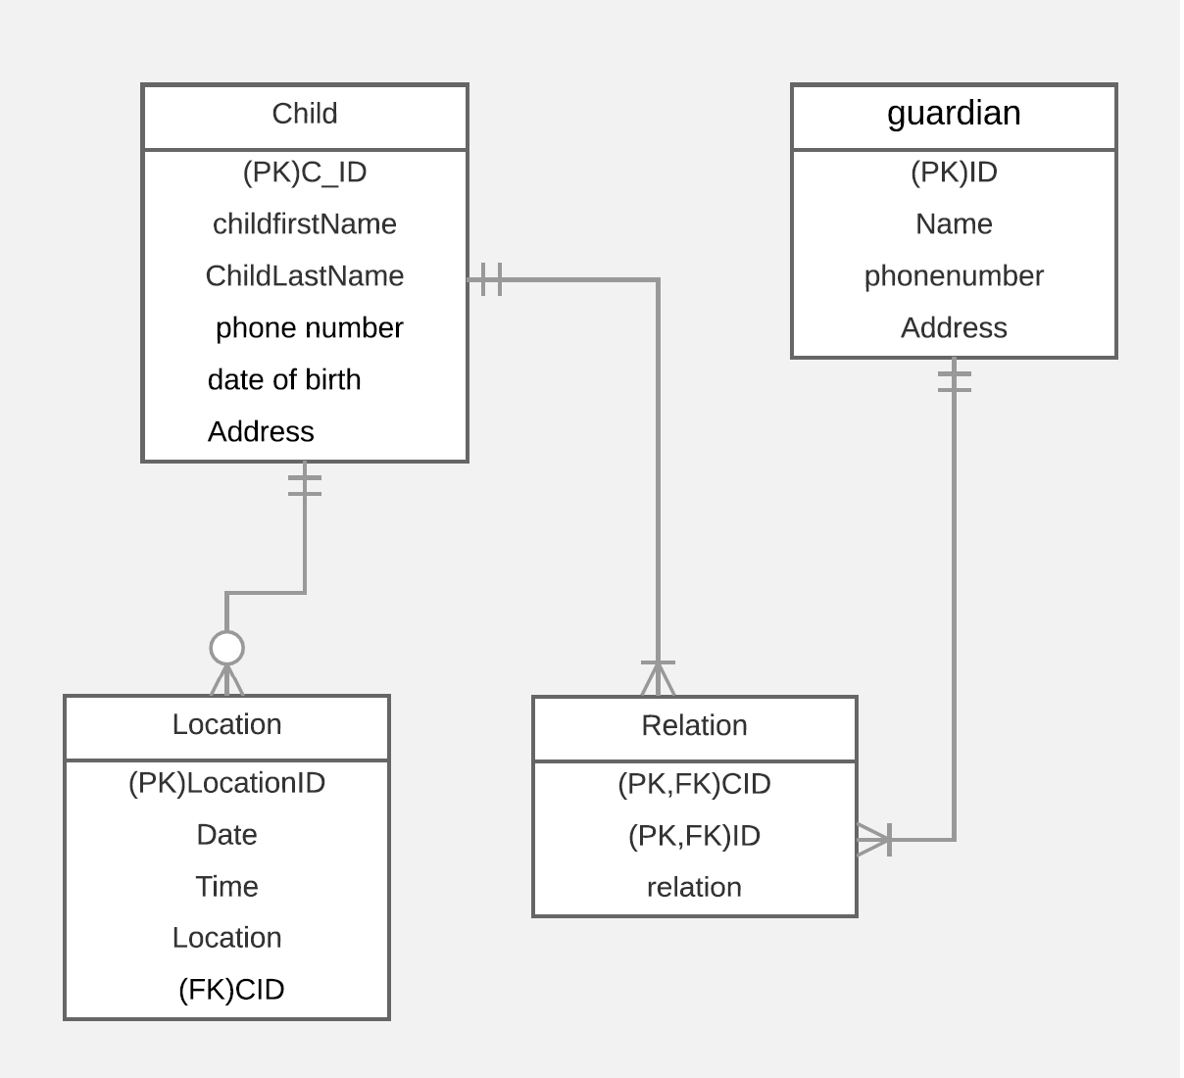

* 1. GUI

First page is Login page, where the user should enter username and password in order to login into the application. It will have Forgot Password and Create account links.

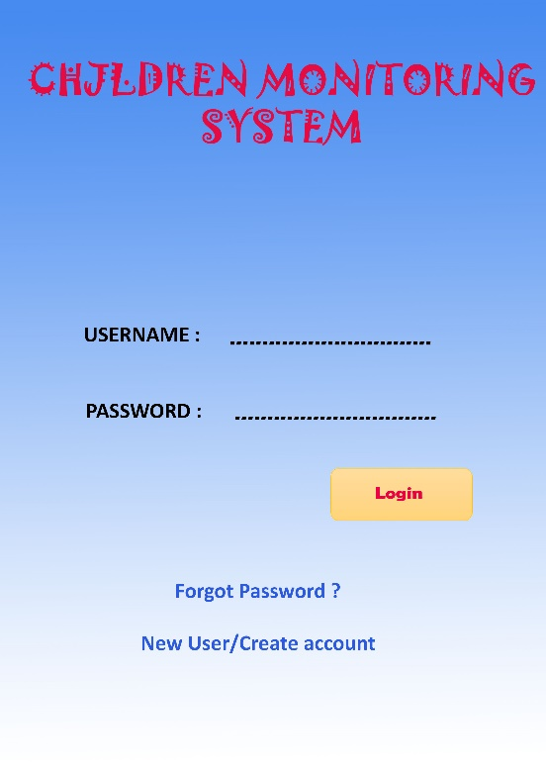

New user link redirects to Signup page where we have to enter all the required details for creating new account.

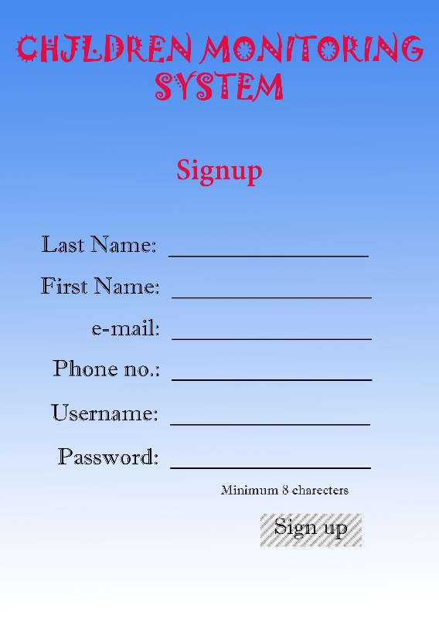

Forgot password page is displayed with email id field and submit button, which gives the link to activate the account again.

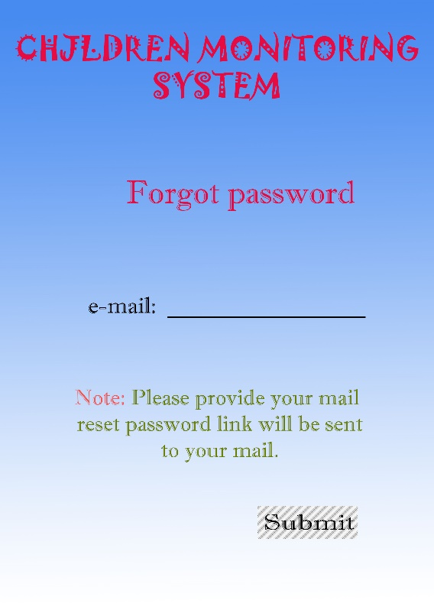

After successful login, home page should be displayed with ‘Add your children’ button and child detail buttons which redirects to Record Management/Child page.

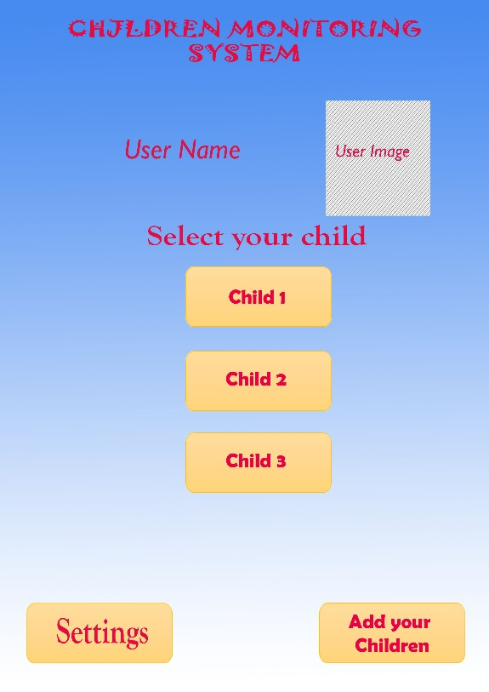

After clicking on any child in Home page, it redirects to Child page where Location, Today activities, See history and Delete child options are displayed.

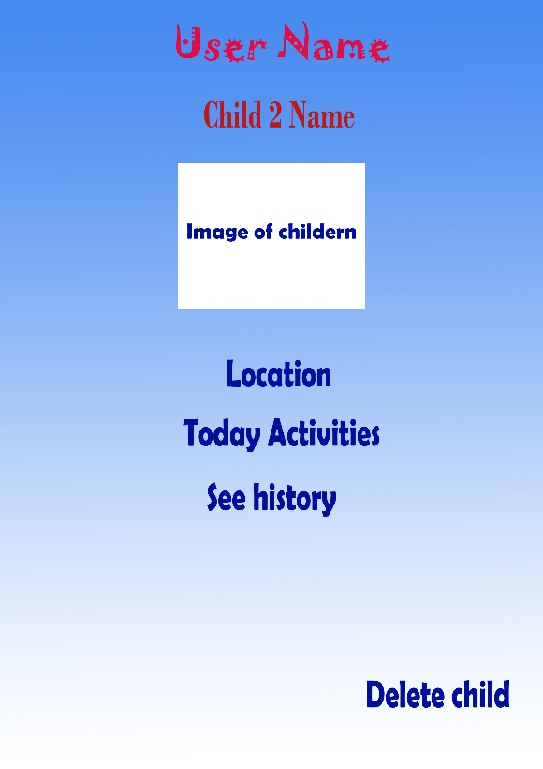

In Settings page, the user (parent) details with image, username, turn off notifications, change password, change name, change phone number, change profile picture options.

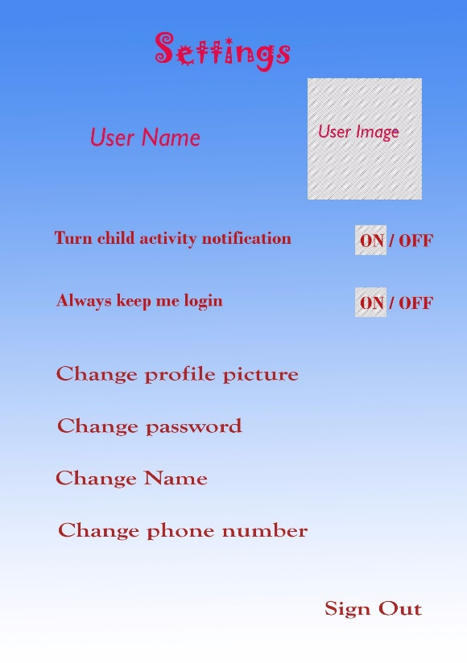

## Analysis Models

* 1. Data Flow Diagram

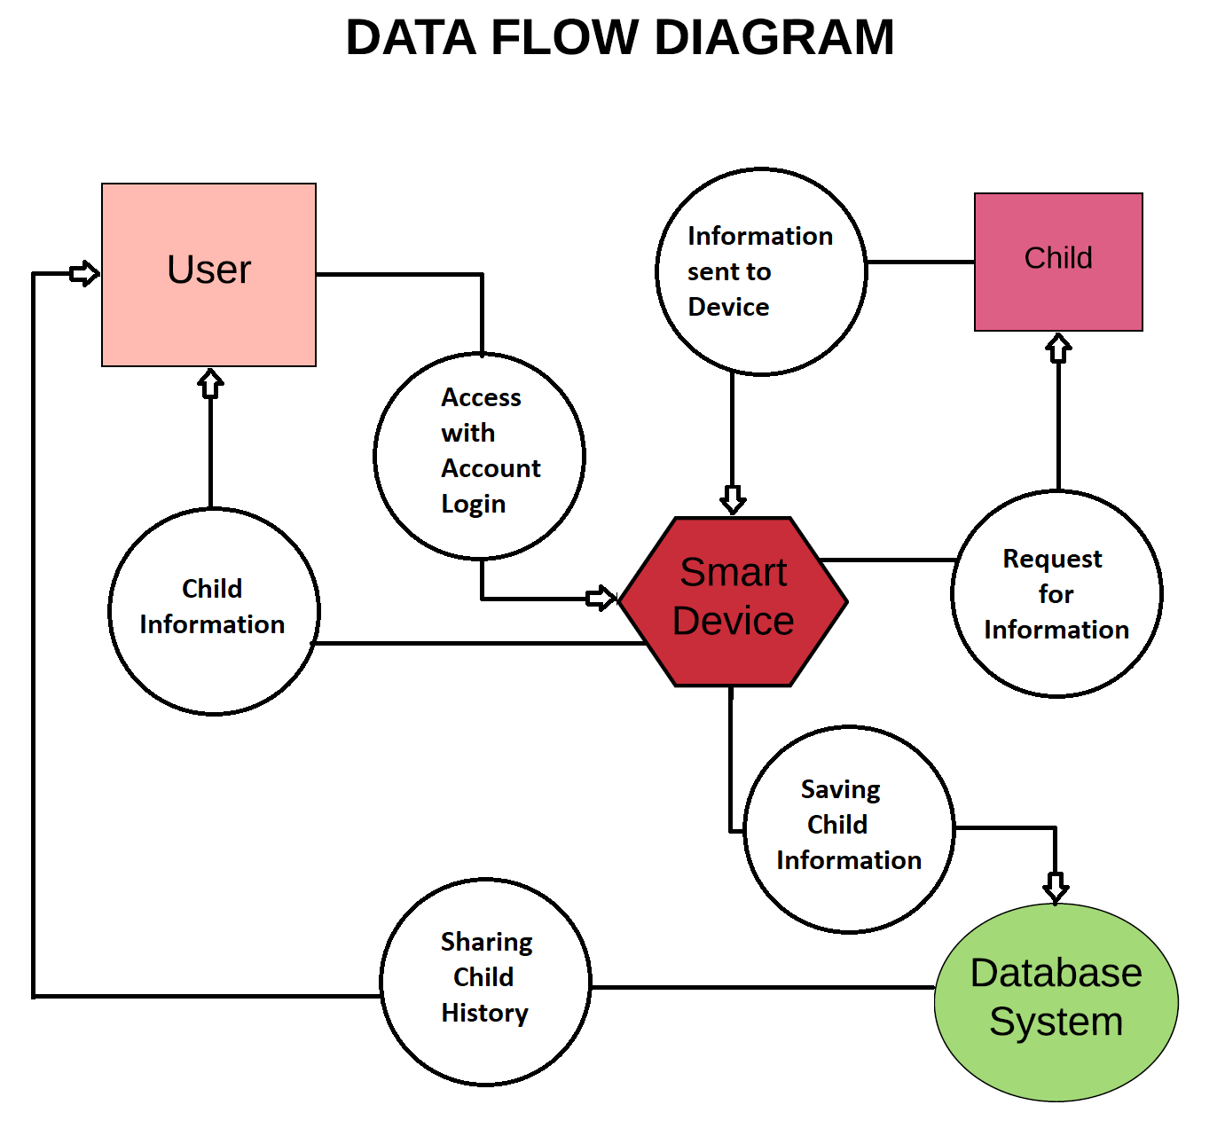

* 1. Sequence Diagram

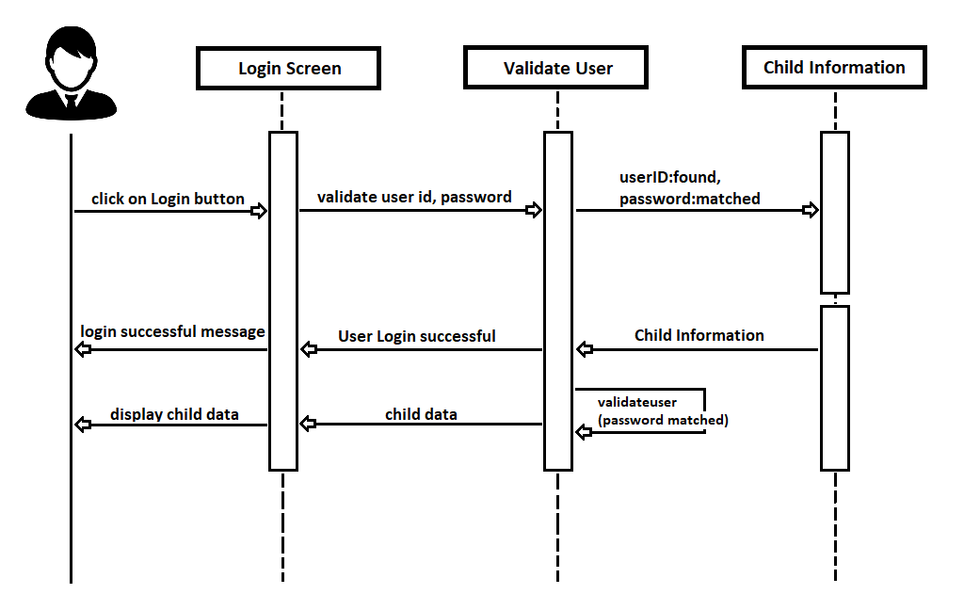

## User Manual

* 1. Install the application

Download and install the application.

* 1. Register for the application

Launch the application and ‘New User/Create account’ link in the page is displayed. Click on the link and it will redirect to ‘Register’ or ‘Sign up’ page as below.



Fill all the mandatory fields and click on ‘Sign up’ button.

* 1. Login

After successful registration, Login page is displayed with username and password fields as below



Enter the username and password given while registering the application and click on Login button.

* 1. Add a Child

After you login to the application with your username and password, Home page is displayed with details as below.

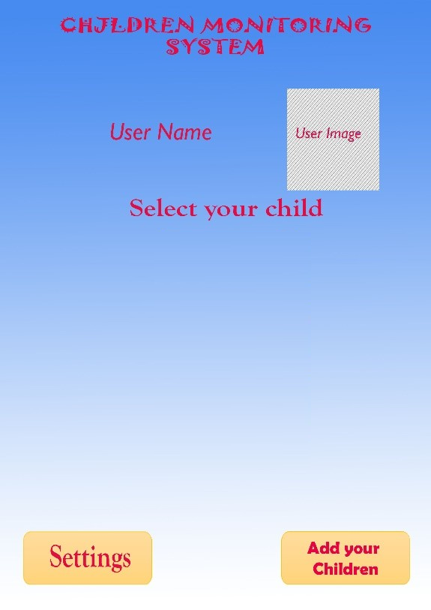

Click on the ‘Add your children’ button and a page is displayed as below. Enter the details and click on ‘Add’ button.

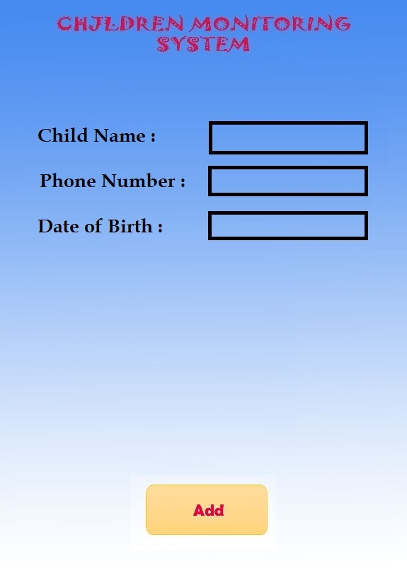

* 1. Track location of the child

After adding a child, Home page is displayed with your added child for example, Child 1 as below.

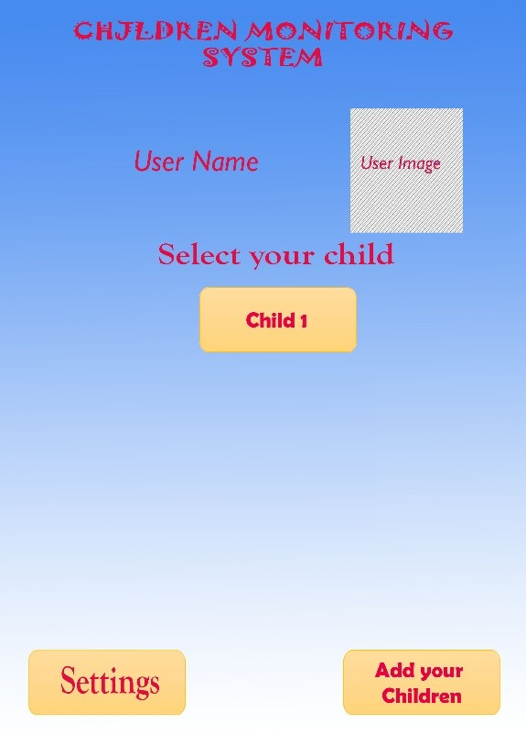

Click on ‘Child 1’ button and Child page is displayed with details as below.

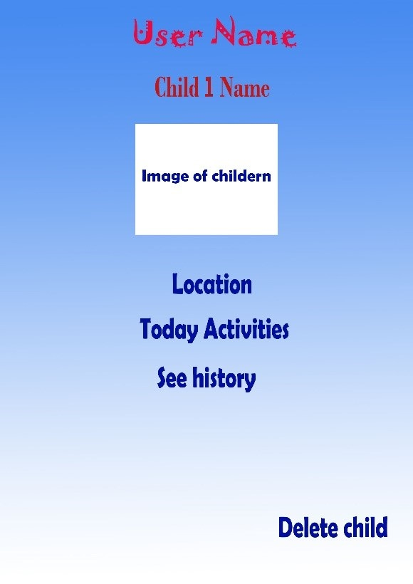

Click on the Location and view the child location as below.

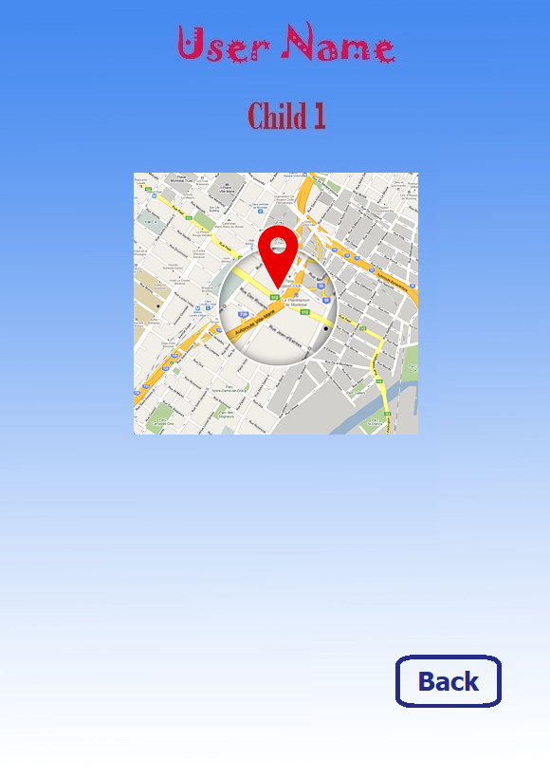

* 1. Track activities of the child

Click on the ‘Today Activities’ button and list of child activities are displayed as below.

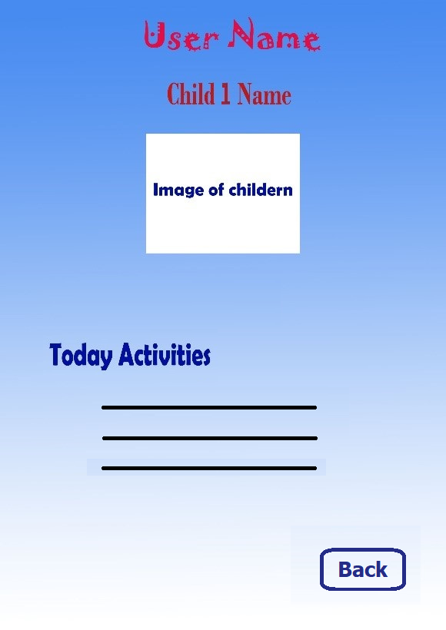

* 1. Track history of the child

Click on the ‘See history’ button and details of child i.e. the list of dates with detailed information is displayed as below.

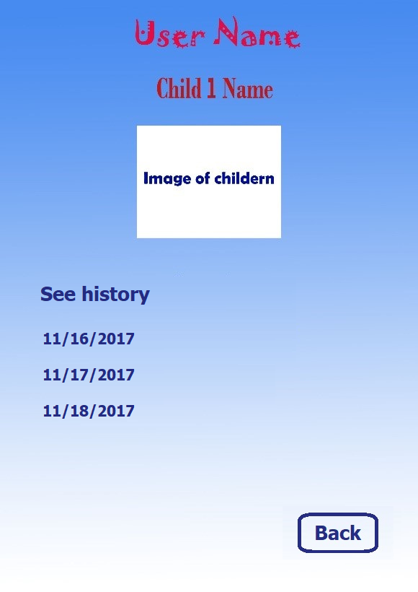

* 1. Change Settings

Change the user (parent) details with image, username, turn off notifications, change password, change name, change phone number and change profile picture options in the Settings page.



## System Manual

* 1. Application Requirements

|  |  |  |
| --- | --- | --- |
| **Requirement SNo.** | **Name** | **Description** |
| 1 | Desktop i.e. Windows or Mac | Desktop or Laptop/ Hardware in order run the application |
| 2 | Android Device | Android mobile device with latest version |
| 3 | iOS Device | iOS mobile device with latest iOS version |

* 1. Application Requirements
     1. Install the application

Download and install the application.

* + 1. Register for the application

Launch the application and ‘New User/Create account’ link in the page is displayed. Click on the link and it will redirect to ‘Register’ or ‘Sign up’ page as below.



Fill all the mandatory fields and click on ‘Sign up’ button.

* + 1. Login

After successful registration, Login page is displayed with username and password fields as below



Enter the username and password given while registering the application and click on Login button.

* + 1. Add a Child

After you login to the application with your username and password, Home page is displayed with details as below.



Click on the ‘Add your children’ button and a page is displayed as below. Enter the details and click on ‘Add’ button.



* + 1. Track location of the child

After adding a child, Home page is displayed with your added child for example, Child 1 as below.



Click on ‘Child 1’ button and Child page is displayed with details as below.



Click on the Location and view the child location as below.



* + 1. Track activities of the child

Click on the ‘Today Activities’ button and list of child activities are displayed as below.



* + 1. Track history of the child

Click on the ‘See history’ button and details of child i.e. the list of dates with detailed information is displayed as below.



* + 1. Change Settings

Change the user (parent) details with image, username, turn off notifications, change password, change name, change phone number and change profile picture options in the Settings page.



* 1. Add a User/ Delete a User
     1. Add a User

Admin can add a user directly in the Backendless. First login into the Backendless application and select the respective project. Click on Data icon and select ‘users’ from ‘System tables’ section. Click on ‘New’ button and enter email, name and password fields and the user with email id is successfully added to the database.

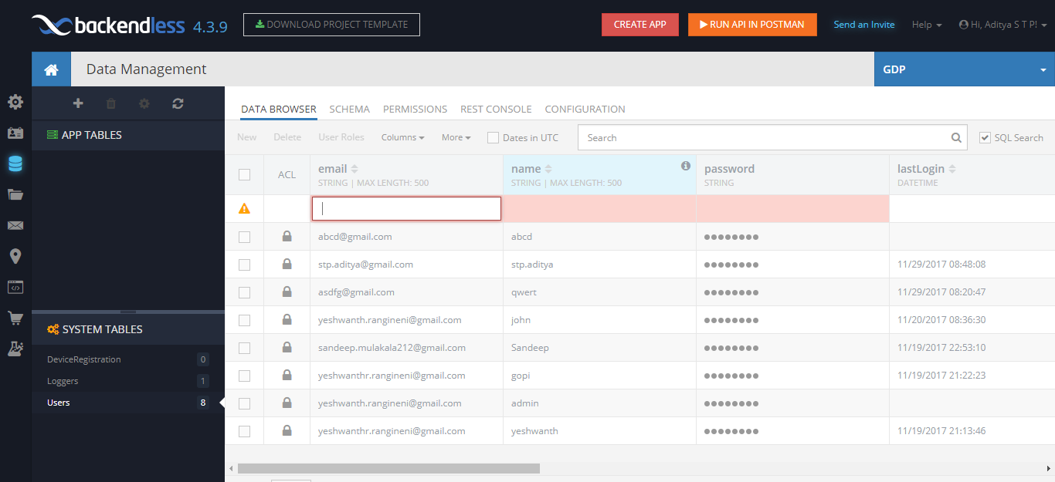

* + 1. Delete a User

Admin can delete a user directly in the Backendless. First login into the Backendless application and select the respective project. Click on Data icon and select ‘users’ from ‘System tables’ section. Select a user with checkbox beside it and click on ‘Delete’ button and the selected user is deleted successfully from the database.

